**Program:5**

**package** codecamp2;

**import** java.util.Scanner;

**public** **class** Palindrome

{

//Main method

**public** **static** **void** main(String args[])

{

String x,y = "";

//creating object for scanner

Scanner sc = **new** Scanner(System.***in***);

System.***out***.print("Enter your string: ");

x = sc.nextLine();

**int** n = x.length();

**for**(**int** i= n-1; i>= 0; i--)

{

y = y + x.charAt(i);

}

**if**(x.equalsIgnoreCase(y))

{

System.***out***.println("Given string is palindrome.");

}

**else**

{

System.***out***.println("Given string is not palindrome.");

}

}

}

**Output:**

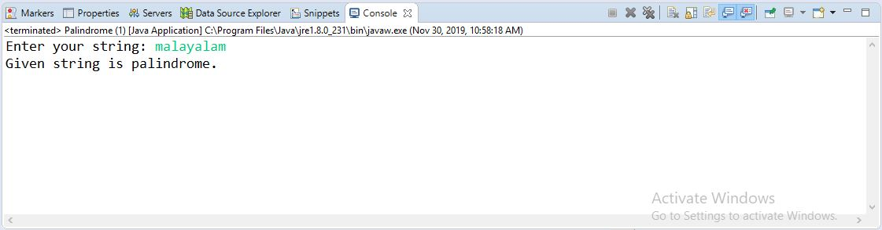

**Program:6**

**package** codecamp2;

**import** java.util.Scanner;

**public** **class** Day {

**public** **static** **void** main(String[] args)

{

**int** temp,temp1,temp2,month, year, week, day;

Scanner sc = **new** Scanner(System.***in***);

System.***out***.println("Enter the number of days:");

temp = sc.nextInt();

year=temp/365;

temp1=temp%365;

System.***out***.println("Total number of years: "+year);

week=temp/7;

month=temp/30;

System.***out***.println("Total number of months: "+month);

temp2=week&7;

System.***out***.println("Total number of weeks: "+week);

day=temp;

System.***out***.println("Total number of days: "+day);

}

}

**Output:**

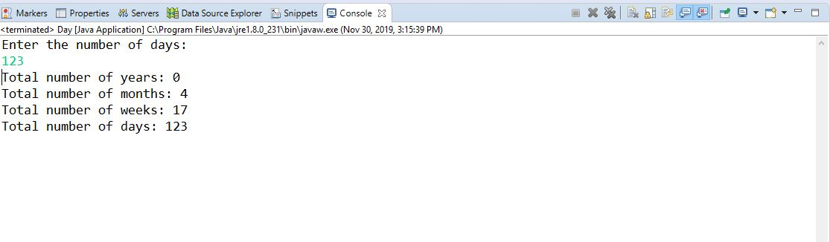

**Program:10**

**package** codecamp2;

**public** **class** Maximum {

**static** **int** *arr*[] = {20, 720, 390, 540, 1000};

// Method to find maximum of arr[]

**static** **int** largest()

{

**int** i;

// Initialize maximum element

**int** max = *arr*[0];

// compare every element with current max

**for** (i = 1; i < *arr*.length; i++)

**if** (*arr*[i] > max)

max = *arr*[i];

**return** max;

}

// Main method

**public** **static** **void** main(String[] args)

{

System.***out***.println("Absolute maximum value of given array is " + *largest*());

}

}

**Output:**

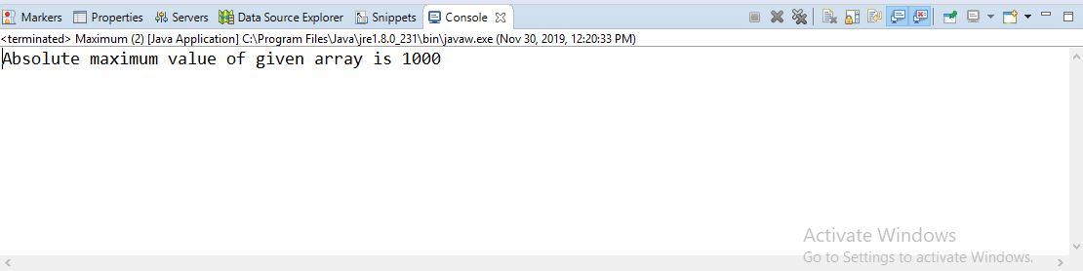

**Program:1**

**package** codecamp2;

**import** java.util.Scanner;

**public** **class** First {

**public** **static** **void** main(String[] args) {

// **TODO** Auto-generated method stub

String ename;

**int** digital,digital2,digital3;

**int** java,java2,java3;

**int** networking,networking2,networking3;

**int** digitalsum,digitalavg;

**int** javaavg,javasum;

**int** networksum,networkavg;

Scanner sc=**new** Scanner(System.***in***);

System.***out***.println("enter scholar1 name");

ename=sc.next();

System.***out***.println("enter marks of digital logic");

digital=sc.nextInt();

System.***out***.println("enter marks of java");

java=sc.nextInt();

System.***out***.println("enter marks of networking");

networking=sc.nextInt();

System.***out***.println("enter Scholar 2 name:");

ename=sc.next();

System.***out***.println("enter marks of digital logic");

digital2=sc.nextInt();

System.***out***.println("enter marks of java");

java2=sc.nextInt();

System.***out***.println("enter marks of networking");

networking2=sc.nextInt();

System.***out***.println("enter Scholar 3 name:");

ename=sc.next();

System.***out***.println("enter marks of digital logic");

digital3=sc.nextInt();

System.***out***.println("enter marks of java");

java3=sc.nextInt();

System.***out***.println("enter marks of networking");

networking3=sc.nextInt();

digitalsum=digital+digital2+digital3;

digitalavg=digitalsum/3;

System.***out***.println("average of Digital-Logic of three scholars is:"+digitalavg);

javasum=java+java2+java3;

javaavg=javasum/3;

System.***out***.println("average of Java of three scholars is:"+javaavg);

networksum=networking+networking2+networking3;

networkavg=networksum/3;

System.***out***.println("average marks in networking of three scholars is:"+networkavg);

}

}

**Output:**

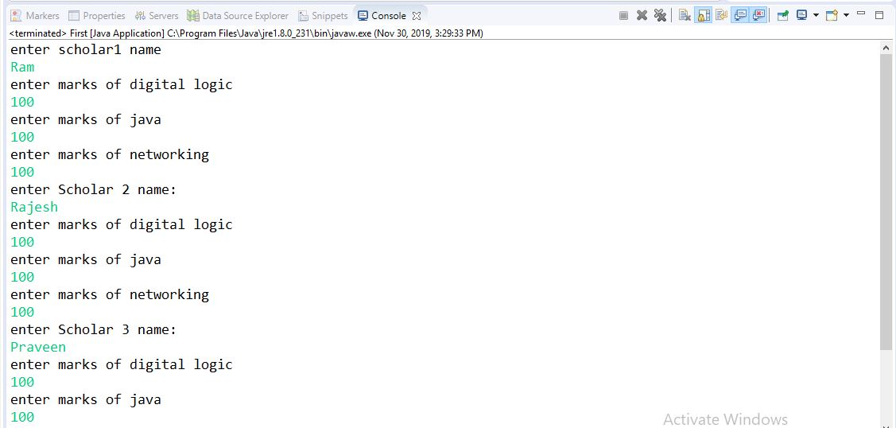

Continue...

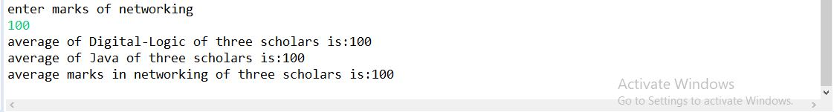

**Program:3**

**package** codecamp2;

**import** java.util.Scanner;

**public** **class** Password {

**public** **static** **final** **int** ***PASSWORD_LENGTH*** = 10;

**public** **static** **void** main(String[] args) {

Scanner input = **new** Scanner(System.***in***);

System.***out***.print(

"1. A password must have at least ten characters.\n" +

"2. A password consists of only letters and digits.\n" +

"3. A password must contain at least two digits \n" +

"Input a password (You are agree the above Terms and Conditions.): ");

String s = input.nextLine();

**if** (*is_Valid_Password*(s)) {

System.***out***.println("Password is valid: " + s);

} **else** {

System.***out***.println("Not a valid password: " + s);

}

}

**public** **static** **boolean** is_Valid_Password(String password) {

**if** (password.length() < ***PASSWORD_LENGTH***) **return** **false**;

**int** charCount = 0;

**int** numCount = 0;

**for** (**int** j = 0; j < password.length(); j++) {

**char** ch = password.charAt(j);

**if** (*is_Numeric*(ch)) numCount++;

**else** **if** (*is_Letter*(ch)) charCount++;

**else** **return** **false**;

}

**return** (charCount >= 2 && numCount >= 2);

}

**public** **static** **boolean** is_Letter(**char** ch) {

ch = Character.*toUpperCase*(ch);

**return** (ch >= 'A' && ch <= 'z');

}

**public** **static** **boolean** is_Numeric(**char** ch) {

**return** (ch >= '0' && ch <= '9');

}

}

**Output:**

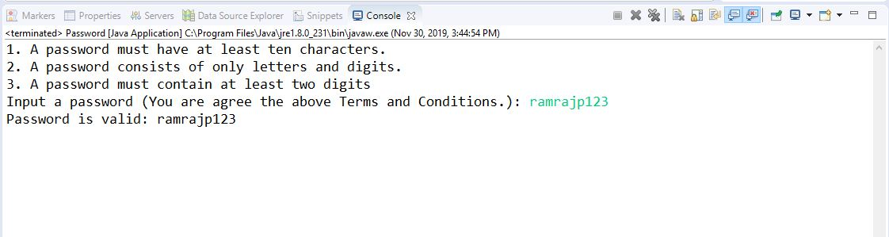

**Program:9**

**package** codecamp2;

**import** java.util.Scanner;

**public** **class** Reversestring

{

**public** **static** **void** main(String[] args)

{

String reverse = "";

**int** len;

System.***out***.println("Enter string to reverse and length : ");

Scanner read = **new** Scanner(System.***in***);

String str = read.nextLine();

len = str.length();

**for**(**int** k = str.length() - 1; k >= 0; k--)

{

reverse = reverse + str.charAt(k);

}

System.***out***.println("Reversed string is:");

System.***out***.println(reverse);

System.***out***.print("Length of Entered String is : " + len);

}

}

**Output:**

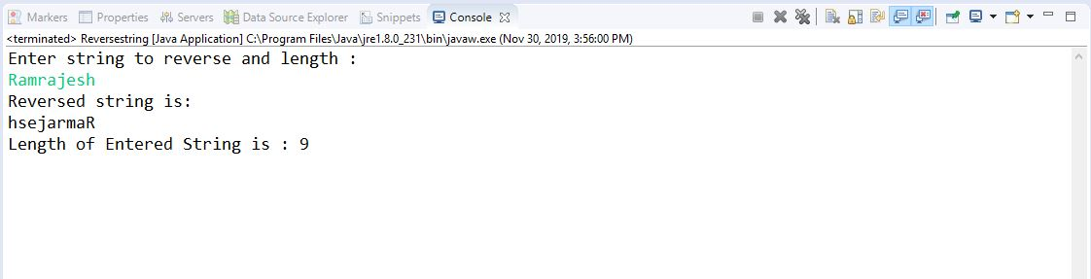

**Program:11**

**package** codecamp2;

**import** java.util.Scanner;

**public** **class** Program11 {

**public** **static** **void** main(String args[])

{

**int** j,space,rows,k=0;

Scanner sc=**new** Scanner(System.***in***);

System.***out***.print("Enter No. of Rows :");

rows=sc.nextInt();

**for** (j=1; j<=rows; j++)

{

**for** (space=1; space<=(rows-j);space++)

{

System.***out***.print(" ");

}

**while** (k!= (2*j-1) )

{

System.***out***.print("*");

k++;

}

k=0;

System.***out***.println();

}

}

}

**Output:**

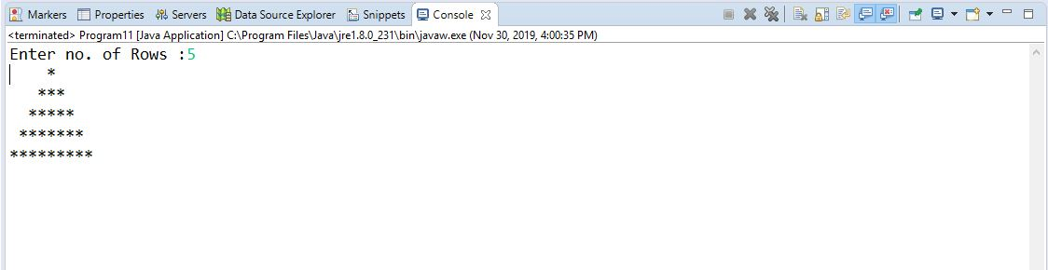

**Program:7**

**package** codecamp2;

**import** java.util.Scanner;

**public** **class** Salary {

**public** **static** **void** main(String args[]) {

Scanner sc=**new** Scanner(System.***in***);

**float** basicSal=0.00f;

**float** HRA=0.0f,DA=0.0f,GrossSal=0.0f;

System.***out***.println("Enter employee basic salary");

basicSal=sc.nextFloat();

**if**(basicSal<1500) {

HRA=0.01f*basicSal;

DA=0.05f*basicSal;

GrossSal=HRA+DA+basicSal;

System.***out***.println("Gross Salary:"+GrossSal);

}

**else** **if**(basicSal>=1500) {

HRA=500;

DA=0.98f*basicSal;

GrossSal=HRA+DA+basicSal;

System.***out***.println("Gross Salary:"+GrossSal);

}

}

}

**Output:**

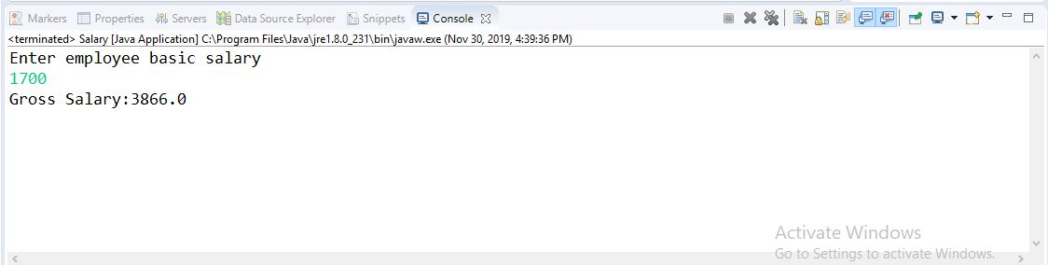

**Program:4**

**package** codecamp2;

**import** java.util.Scanner;

**public** **class** Stringcharacter

{

**public** **static** **void** main(String[] args)

{

Scanner sc=**new** Scanner(System.***in***);

System.***out***.println("Enter a string");

String string=sc.next();

**int** length=string.length();

**if**(length%2!=0)

{

**char** c= (**char**) string.codePointAt(length/2);

System.***out***.println("The middle character is "+c);

}

**else**

{

**char** c1= (**char**) string.codePointAt((length/2)-1);

**char** c2= (**char**) string.codePointAt(length/2);

System.***out***.println("The middle characters are "+c1+" "+c2);

}

}

}

**Output:**

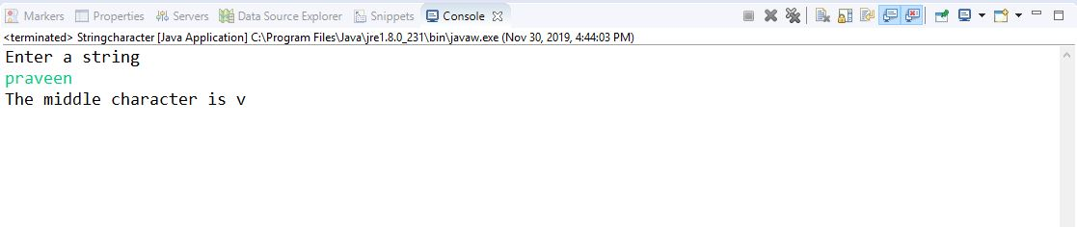

**Program:8**

**package** codecamp2;

**import** java.util.Scanner;

**public** **class** Arraysmall {

**public** **static** **int** getSmallest(**int**[] a, **int** total){

**int** temp;

**for** (**int** j = 0; j < total; j++)

{

**for** (**int** k = j + 1; k < total; k++)

{

**if** (a[j] > a[k])

{

temp = a[j];

a[j] = a[k];

a[k] = temp;

}

}

}

**return** a[0];

}

**public** **static** **void** main(String args[]){

**int** b[]={52,63,97,81,54,98,11,4,12,17};

System.***out***.println("Smallest of an array is: "+*getSmallest*(b,10));

}

}

**Output:**

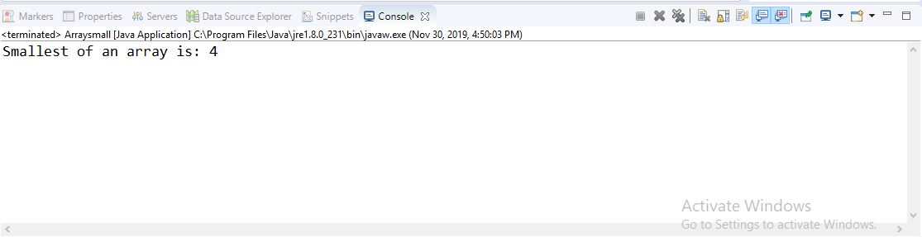

**Program:2**

**package** codecamp2;

**import** java.util.Scanner;

**public** **class** Arrayvalues

{

**public** **static** **void** main(String[] args)

{

**int** flag=0;

**int**[] array1=**new** **int**[5];

**int**[] array2=**new** **int**[5];

Scanner sc=**new** Scanner(System.***in***);

System.***out***.println("Enter First array elements");

**for**(**int** i=0;i<5;i++)

{

array1[i]=sc.nextInt();

}

System.***out***.println("Enter Second array elements");

**for**(**int** i=0;i<5;i++)

{

array2[i]=sc.nextInt();

}

//comparing elements in two arrays

**for**(**int** i=0;i<5;i++)

{

**for**(**int** j=0;j<5;j++)

{

**if**(array1[i]==array2[j])

{

System.***out***.println("common element is "+array1[i]);

i++;

flag=1;

}

}

}

**if** (flag==0)

System.***out***.println("Distinct elements");

}

}

**Output:**

